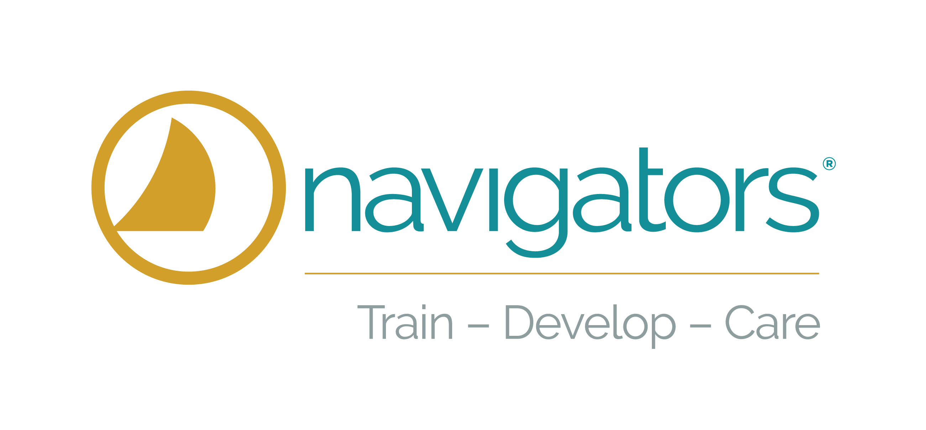

The Navigators
Seminary Associations

The Navigators is grateful to have mutually respectful relationships with many formal institutions of theological education in the U.S. The following institutions have formed associations with us to provide special consideration for Navigator staff through tuition discounts and advanced credit for ministry involvement. Click or contact Train – Develop – Care (TDC@navigators.org) for more information.

- Covenant Theological Seminary (St Louis) www.covenantseminary.edu
- Dallas Theological Seminary (Dallas) http://www.dts.edu/firstclassfree/navigators/
- Denver Theological Seminary (Denver, CO) www.denverseminary.edu
- Fuller Theological Seminary (Pasadena) http://fuller.edu/
- TEDS – Trinity Evangelical Divinity School (Chicago) http://divinity.tiu.edu/
- Western Theological Seminary (Portland, OR) http://westernsem.edu
- Gordon Conwell Theological Seminary | gordonconwell.edu

