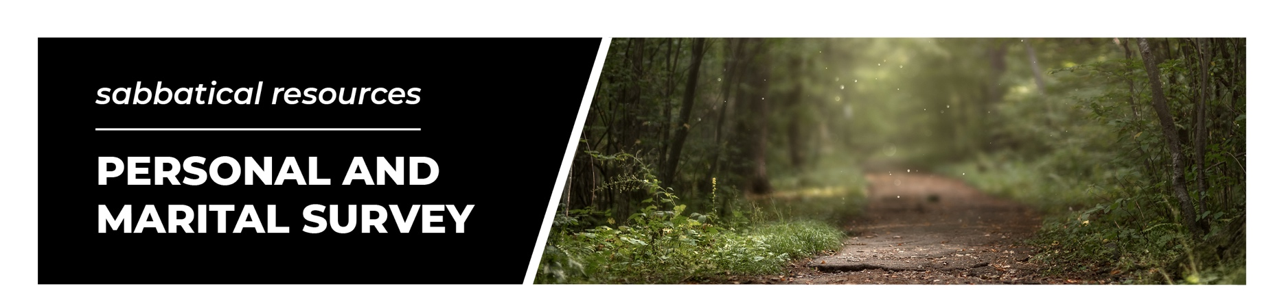
Each spouse should fill out a separate survey. Information will be kept confidential.

GENERAL INFORMATION
In what area or areas of difficulty would you like help?

What results you would like to see?

OPTIONAL QUESTION: HIPAA regulations protect your privacy. If you’re comfortable, please list
any physical conditions that may impact your sabbatical.

OPTIONAL QUESTION: When was the last time you had a physical?

Please indicate any conditions that apply to you:

 | Headaches |  |  | Eating disorder |  |  | Work difficulty |  |  | Drug problems
 | Insomnia |  |  | Loss of hope |  |  | Weight gain |  |  | Alcohol problems
 | Fear |  |  | Difficulty relaxing |  |  | Anger |  |  | Nervousness
 | Loneliness |  |  | Learning difficulties |  |  | Marital difficulty |  |  | Stomach problems
 | Indecisiveness |  |  | Tiredness |  |  | Attention deficit |  |  | Suicidal thoughts
 | Racing heartbeat |  |  | Anxiety |  |  | Sleep too much |  |  | Memory loss
 | Constipation |  |  | Panic attacks |  |  | Strange thoughts |  |  | Problems at home
 | Vomiting |  |  | Dizziness |  |  | Sexual addiction |  |  | Loss of initiative
 | Abandonment |  |  | Fainting |  |  | Appetite loss |  |  | Phobias
 | Smoking |  |  | Depression |  |  | Abusive to spouse |  |  | Obsessions
 | Abuse by spouse |  |  | Inferiority |  |  | High blood pressure |  |  | Problems with parents
 | Weight loss |  |  | Nerves |  |  | Nightmares |  |  | Economic difficulty
 | Guilt |  |  | Rejection |  |  | Irritability |  |  | Difficulty concentrating
 | Problems with pornography |  |  | Difficulties with friendships |  |  | Sexual control problems

Do any other physical/emotional conditions apply to you?

STRESS LEVEL
How would you evaluate your level of stress on a rating of 1-10 (10 = high stress)? Explain.

Are you struggling with attitudes such as resentment, anxiety, fear, pride, etc.?

How would you rate the level of pressure you feel to perform and succeed?

What relaxes and refreshes you?

How would you evaluate your level of restlessness?

RELATIONSHIPS
Do you have unresolved conflicts with people that need to be addressed?

Do you experience feelings of loneliness, isolation, or insecurity?

PERSONAL DEVELOPMENT
What have you always wanted to do but never had the time?

In what character areas do you feel the need to grow?

In what ways are you developing your God-given gifts and design?

SPIRITUAL INTIMACY
Assess your spiritual intimacy with God by assigning each aspect a number from 1 to 10 (10 = excellent).

My intimacy with Christ is truly vibrant and growing.
The Word and Spirit of God are speaking to me and guiding my mind, decisions, and significant relationships.
I have passages and promises from God for life and ministry that motivate me in my walk with Him.
In my time alone with God I’m growing in thankfulness, praise, and worship.
Intercessory prayer tends to be foundational to everything I do.
I’m praying and believing God for my life, ministry, and significant relationships.
My spiritual disciplines are strong and consistent.
My motivation to live a life of devotion to Christ in purity of heart, ministering out of interest in the welfare of others, is strong.
The joys, hardships, sufferings, and circumstances of my life are drawing me to a deeper love for and dependence on Christ.
I have a consistent inner sense that God deeply loves me, is present within me, is for me, and is active in my life.

Is there a spiritual discipline that I sense is weak and would like to grow in?

Reflect on the above parameters of your spiritual life, as well as any others that come to mind. Talk to God about them and ask Him to speak to you. Is He putting His finger on some area of your spiritual life, urging you to develop in it? If so, what?

MARITAL INTIMACY
Independently of one another, please assess the following areas of your marriage by assigning each aspect of intimacy a number from 1 to 10 (10 = excellent). Then enter your spouse’s ratings and compare.

ASPECT OF INTIMACY | View of  HUSBAND | View of  WIFE
Our spiritual closeness through prayer and sharing the Word together is rich.
Frequent times of quality communication and special times away together are high priority.
We practice honest confession and genuine forgiveness when we hurt one
another.
My spouse is good at sharing appreciation, and at speaking and showing love.
My spouse and I often agree on important issues concerning values and beliefs.
We generally understand and appreciate each other’s differences.
We often share deep feelings and strong emotions like grief, sadness, and joy.
We give each other undivided attention when listening or talking.
Our communication is characterized by sharing on important and significant issues.
The handling of finances isn’t usually a source of tension in our relationship.
My spouse and I understand and accept our marital roles.
My spouse is responsive and sensitive to my needs and desires concerning our relationship.
My spouse and I experience community and meaningful relationships with a few close friends.
We’re comfortable in our relationship with our children.
My spouse and I take part together in recreation, relaxation, and rest.
We have good and meaningful relationships with our in-laws and parents.
We partner together in some areas of common interests, and in ways that are consistent with individual design and desires.
Generally I am satisfied with our level of sexual intimacy.

ASSESSING YOUR LEVEL OF INTIMACY
Record your responses to the questions and share with one another. Identify and talk about areas of significant agreement and disagreement.

AREAS OF AGREEMENT | AREAS OF DISAGREEMENT
•  •  • | •  •  •

As a couple, what are your three greatest strengths?

As a couple, what are your three greatest weaknesses?

Identify and agree on one or two issues as most important to focus on during your sabbatical.

CAREGIVING AND COUNSELING
Is there anything else you’d like to discuss or explore?

Is there any area in which you seem unable to make progress on your own?

Have you seen counselors in the past? In what areas did you seek help? Was it helpful to you? If so, how?

